**Database Management System**

**Final Term**



**Spring 2021**

**CSE403 DBMS**

Submitted by: **Shah Raza**

Registration No. : **18PWCSE1658**

Class Section: **B**

“On my honor, as student of University of Engineering and Technology, I have neither given nor received unauthorized assistance on this academic work.”

Student Signature: ______________

Submitted to:

**Engr. Summayea Salahuddin**

Wednesday, July 28, 2021

**Department of Computer Systems Engineering**

**University of Engineering and Technology, Peshawar**

**Normalization:**

**ERD:**

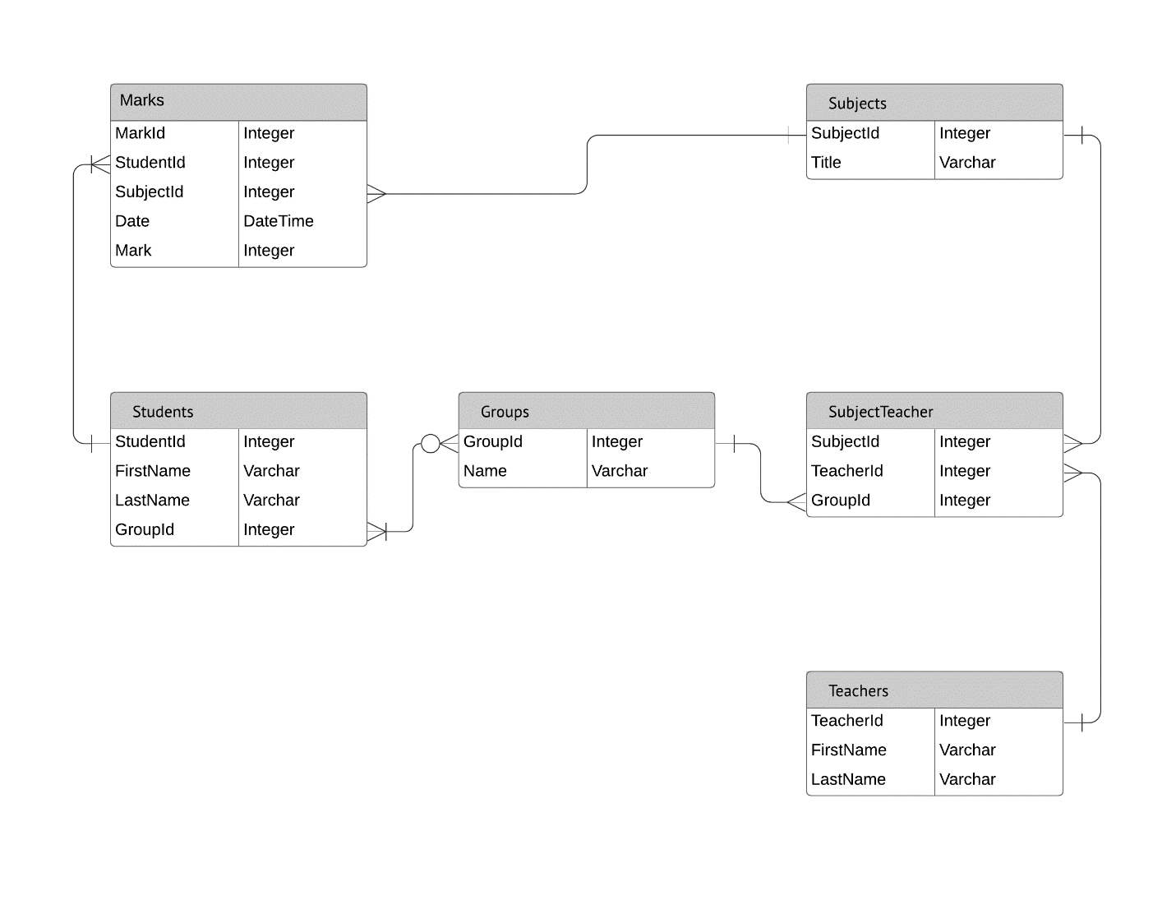

Link: <https://lucidchart.zendesk.com/hc/article_attachments/360040348272/EX__Database_ER_Diagram__Crow_s_Foot_.png>

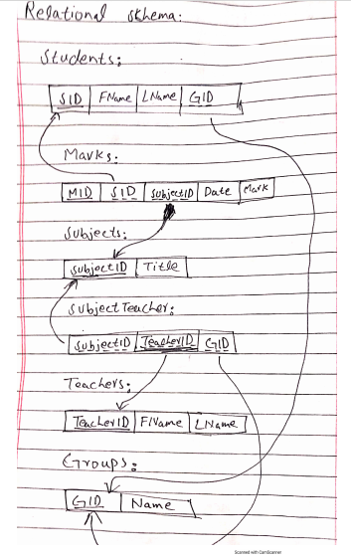

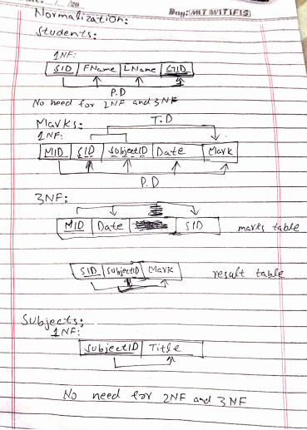

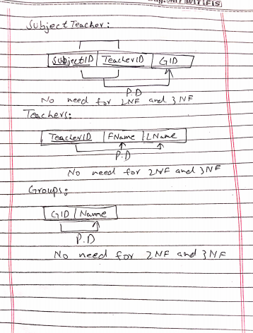

**Database 1:**

Microsoft Windows [Version 10.0.19043.1110]

(c) Microsoft Corporation. All rights reserved.

C:\Users\Shah Raza>e:

E:\>cd E:\xampp\mysql\bin

E:\xampp\mysql\bin>mysql.exe -u root

Welcome to the MariaDB monitor. Commands end with ; or \g.

Your MariaDB connection id is 8

Server version: 10.4.18-MariaDB mariadb.org binary distribution

Copyright (c) 2000, 2018, Oracle, MariaDB Corporation Ab and others.

Type 'help;' or '\h' for help. Type '\c' to clear the current input statement.

MariaDB [(none)]> create database final;

Query OK, 1 row affected (0.028 sec)

MariaDB [(none)]> use final

Database changed

MariaDB [final]> create table students (

-> SID primary key not null,

-> Fname ;

ERROR 1064 (42000): You have an error in your SQL syntax; check the manual that corresponds to your MariaDB server version for the right syntax to use near 'primary key not null,

Fname' at line 2

MariaDB [final]> create table students (

-> SID int primary key not null,

-> Fname varchar(30),

-> Lname varchar(30),

-> GID fore;

ERROR 1064 (42000): You have an error in your SQL syntax; check the manual that corresponds to your MariaDB server version for the right syntax to use near '' at line 5

MariaDB [final]> create table groups(

-> GID int primary key not null,

-> Name varchar(30)

-> );

Query OK, 0 rows affected (0.265 sec)

MariaDB [final]> create table students (

-> SID int primary key not null,

-> Fname varchar(30),

-> Lname varchar(30),

-> GID int,

-> foreign key(GID) references groups(GID)

-> );

Query OK, 0 rows affected (0.278 sec)

MariaDB [final]> create table results(

-> jshd;

ERROR 1064 (42000): You have an error in your SQL syntax; check the manual that corresponds to your MariaDB server version for the right syntax to use near '' at line 2

MariaDB [final]> create table subjects(

-> subjectID int primary key not null,

-> Title varchar(30)

-> );

Query OK, 0 rows affected (0.257 sec)

MariaDB [final]> create table results(

-> SID int primary key not null,

-> subjectID int,

-> Mark int,

-> foreign key(SID) references students(SID),

-> foreign key(subjectID) references subjects(subjectID)

-> );

Query OK, 0 rows affected (0.312 sec)

MariaDB [final]> create table marks(

-> MID int primary key not null,

-> Date date,

-> SID int,

-> foreign key(SID) references results(SID)

-> );

Query OK, 0 rows affected (0.202 sec)

MariaDB [final]> show tables;

+-----------------+

| Tables_in_final |

+-----------------+

| groups |

| marks |

| results |

| students |

| subjects |

+-----------------+

5 rows in set (0.001 sec)

MariaDB [final]> create table teachers(

-> teacherID int primary key not null,

-> Fname varchar(30),

-> Lname varchar(30)

-> );

Query OK, 0 rows affected (0.202 sec)

MariaDB [final]> create table subjectTeacher(

-> subjectID int primary key not null,

-> teacherID int primary key not null,

-> GID int,

-> foreign key(subjectID) references subjects(subjectID),

-> foreign key(teacherID) references teachers(teacherID),

-> foreign key(GID) references groups(GID)

-> );

ERROR 1068 (42000): Multiple primary key defined

MariaDB [final]> create table subjectTeacher(

-> subjectID int,

-> teacherID int,

-> GID int,

-> foreign key(subjectID) references subjects(subjectID),

-> foreign key(teacherID) references teachers(teacherID),

-> foreign key(GID) references groups(GID),

-> primary key(subjectID,teacherID)

-> );

Query OK, 0 rows affected (0.207 sec)

MariaDB [final]> insert into groups values

-> (1,'Hunters'),

-> (2,'Scholars'),

-> (3,'Killers'),

-> (4,'Snakes'),

-> (5,'Losers');

Query OK, 5 rows affected (0.064 sec)

Records: 5 Duplicates: 0 Warnings: 0

MariaDB [final]> insert into students values

-> (1,'Shah','Raza',1),

-> (2,'Ashiq','Ullah',2),

-> (3,'Zohaib','Saeed',3),

-> (4,'Muhammad','Zulkifal',4),

-> (5,'Hassan','Mehmood',5);

Query OK, 5 rows affected (0.091 sec)

Records: 5 Duplicates: 0 Warnings: 0

MariaDB [final]> insert into subjects values

-> (1,'DBMS'),

-> (2,'MBSD'),

-> (3,'DSD'),

-> (4,'TW'),

-> (5,'DCN');

Query OK, 5 rows affected (0.078 sec)

Records: 5 Duplicates: 0 Warnings: 0

Database 2:

MariaDB [final]> create procedure p1(in id int)

-> begin

-> select Fname from students where SID =id;

-> end $$

Query OK, 0 rows affected (0.152 sec)

MariaDB [final]> call p1(1);

-> $$

+-------+

| Fname |

+-------+

| Shah |

+-------+

1 row in set (0.049 sec)

Query OK, 0 rows affected (0.053 sec)

MariaDB [final]> create procedure p2(in id int)

-> begin

-> select * from groups where GID>id;

-> end $$

Query OK, 0 rows affected (0.204 sec)

MariaDB [final]> call p2(1)$$

+-----+----------+

| GID | Name |

+-----+----------+

| 2 | Scholars |

| 3 | Killers |

| 4 | Snakes |

| 5 | Losers |

+-----+----------+

4 rows in set (0.031 sec)

Query OK, 0 rows affected (0.047 sec)

MariaDB [final]> create trigger group3 before insert on students for each row

-> begin

-> if new.SID>5 then

-> set new.GID = 3;

-> end if;

-> end $$

Query OK, 0 rows affected (0.122 sec)

MariaDB [final]> create function showid(name varchar(30))

-> return int

-> begin

-> declare id int;

-> select SID into id from students where Fname = name;

-> return id;

-> end $$